Lab 11: Heap sort & Priority Queue CLO2,PLO4,P4

Objective(s): Upon completion of this lab session, students will be able to:
Implement heap sort
Implement priority queue

Exercise 1: Cricket Player Performance
Develop a program to build a max heap for a collection of cricket players based on their performance ratings to enhance team management by prioritizing high-performing players. Write a program in C++ and perform the following tasks:
- Insert player names along with their performance ratings.
- Build a max heap to organize players by their performance.
- Display the players in the heap.
- Find the highest-rated player.
- Delete a player from the heap (e.g., when a player is injured or dropped from the team).
Sample Output:
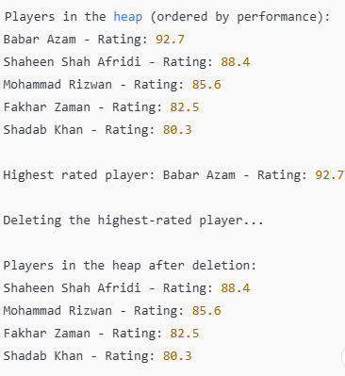
Exercise 2: Prioritizing Recipes by Cooking Time
Develop a program to manage a collection of recipes based on their cooking times using a min heap and heap sort. The program should allow the insertion of recipes along with their cooking times, build a min heap to organize the recipes with the shortest cooking time at the root, and display the recipes in the heap. Additionally, the program should perform heap sort to sort the recipes in increasing order of their cooking times. The program should also be able to find and display the recipe with the shortest cooking time.
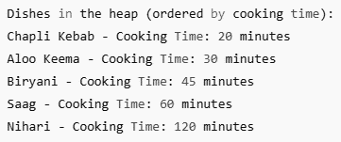
Exercise 3: Patient’s Priority Queue
There are different patients of different age group visit to Dr. ABC for treatment. They are waiting in a queue in FIFO fashion. Dr. ABC attends the patient to facilitate them in following order.
Emergency patient visit first then old age patient, then children, then new patients, then regular patients.
Priorities are given as
- Emergency patient
- Old age patients
- Children
- New patient
- Regular Patients.
Design a program that facilitates the patient as per the given priority and display the priority queue.

